AI APPLICATION NOTES
GRADE 7

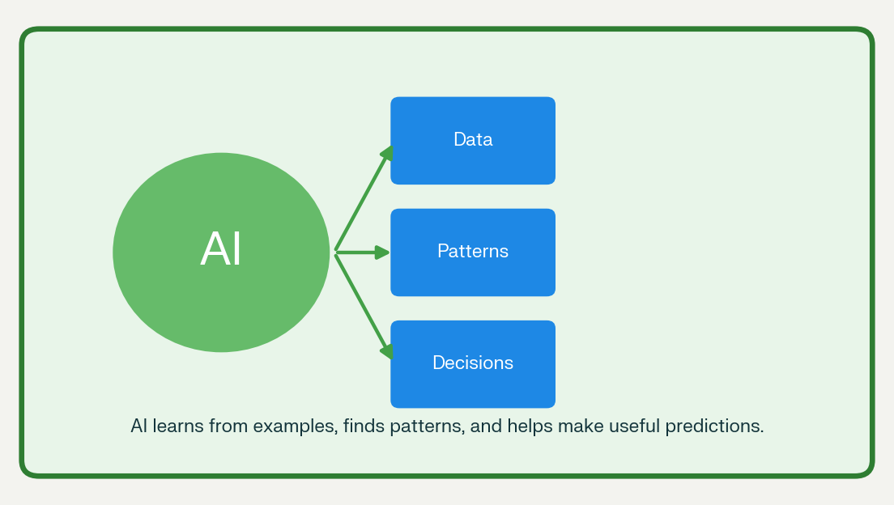
AI in Money Matters
AI for a Greener World

Theory • Colourful Images • Worksheets • Activities
25-page attractive student workbook

What You Will Learn
Topic | Learning outcome
AI basics | Explain what Artificial Intelligence means in simple words.
Money matters | Use AI ideas for budgeting, saving, smart spending, and banking safety.
Greener world | Explain how AI saves energy and water, reduces waste, and protects nature.
Responsible AI | Understand privacy, safety, mistakes, and the need for human checking.

Why learn about AI?
AI is already used in mobile apps, banks, schools, farms, weather services, and recycling centres. Learning about it helps students use technology wisely and solve real-life problems.

Unit 1: AI in Money Matters

1.1 What is Artificial Intelligence?
Artificial Intelligence, or AI, is computer technology that can learn from information, find patterns, and help people make decisions. AI can process large amounts of data much faster than a person.
AI does not have feelings or think exactly like a human. It follows steps designed by people and learns from examples called data.
AI learns from data, finds patterns, makes predictions, and improves through feedback.
Word | Meaning
AI | Computer technology that learns from data and helps make decisions.
Data | Information such as numbers, pictures, sounds, or spending records.
Algorithm | A set of steps a computer follows to solve a problem.
Prediction | A smart guess about what may happen next.
Budget | A plan for income, spending, and saving.
Fraud | Dishonest activity used to steal money or personal information.

1.2 Why AI Helps in Money Matters
Managing money means planning how to earn, spend, save, and protect money. Many people find it difficult to remember every expense. AI can study spending records and give useful advice.
- It can record expenses automatically.
- It can group expenses into food, travel, school, entertainment, and savings.
- It can warn users when spending becomes too high.
- It can suggest a savings goal.
- It can detect unusual bank activity.
- It can answer simple money questions through a chatbot.
Example
Riya gets Rs. 500 every month. Her AI app shows that she spends Rs. 200 on snacks, Rs. 100 on stationery, Rs. 100 on travel, and saves Rs. 100. The app notices that snacks use 40% of her money and suggests reducing snack spending.

1.3 AI in Budgeting
A budget is a plan for money. AI budgeting tools compare income and expenses, find patterns, and suggest better choices.
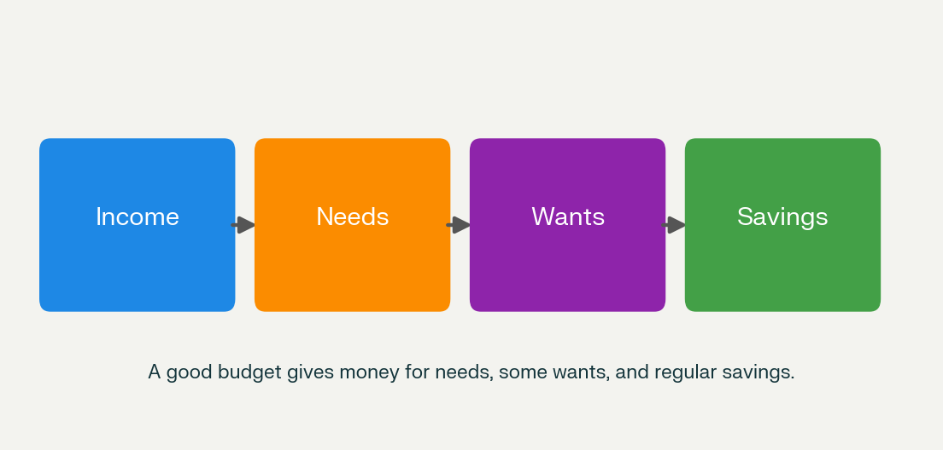
AI can help divide income among needs, wants, and savings.
AI can do | How it helps
Track expenses | Records money spent through bills, bank messages, or user entries.
Categorise spending | Places expenses into groups such as food, travel, and education.
Create a budget | Suggests limits for each spending category.
Predict spending | Uses past data to estimate next month’s expenses.
Set saving goals | Helps users plan how much to save each month.
Send alerts | Warns users before they cross their budget limit.

Remember
AI gives suggestions, but people must enter correct information and check the advice before following it.

1.4 AI in Saving and Smart Spending
AI can help people save by finding small expenses that can be reduced. It can also compare prices and suggest better choices.
- Price comparison: AI compares prices of the same product on different websites.
- Expense review: AI shows where most money is spent.
- Saving reminders: AI reminds users to save regularly.
- Goal tracking: AI shows progress toward a target amount.
- Smart recommendations: AI suggests lower-cost alternatives.
- Pattern analysis: AI finds repeated unnecessary purchases.
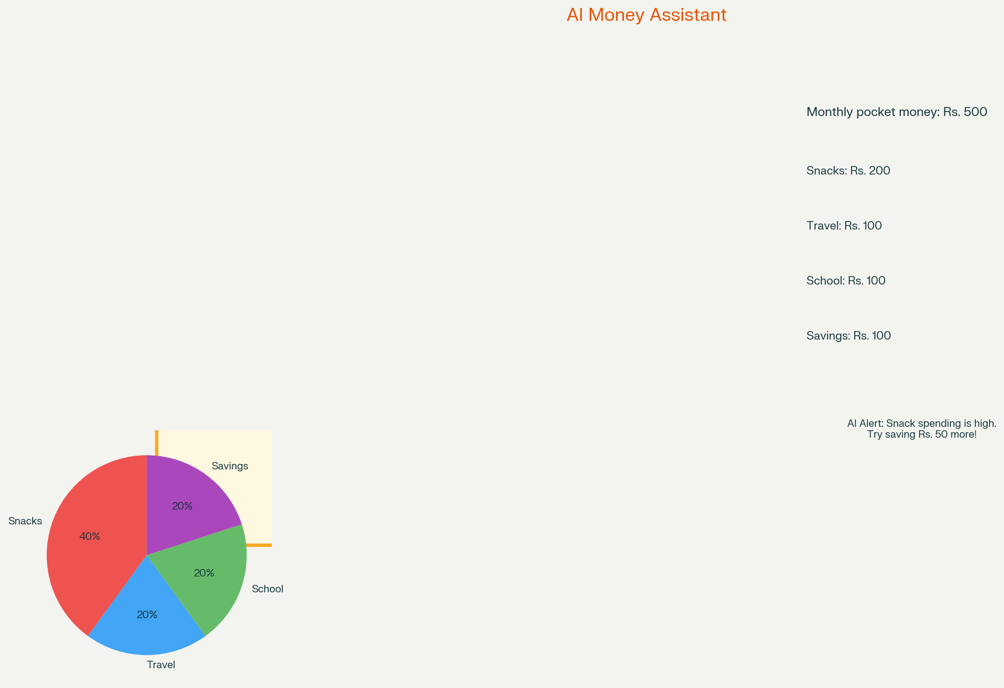
An AI money assistant can show spending categories and give helpful alerts.

1.5 AI in Banking and Fraud Detection
Banks use AI to keep accounts safe. AI studies normal activity, such as usual spending places, amounts, and times. If something unusual happens, AI can send an alert or block a suspicious transaction.
Normal activity | Possible fraud alert
Small purchases in your city | A large purchase in another country within minutes.
Regular daytime spending | A transaction at an unusual time.
Purchases from known shops | Repeated attempts to use a card on unknown websites.
Normal login location | Login from a new device or unfamiliar location.

Important
AI can make mistakes. A genuine transaction may be marked suspicious. Banks therefore ask customers to confirm unusual activity.

Worksheet 1: AI in Money Matters
Name: ______________________________ Class: 7 Date: __________

A. Fill in the blanks
- AI stands for ___________________________________.
- A plan for income, spending, and saving is called a ___________________.
- AI can detect __________________ transactions in a bank account.
- Information used by AI to learn is called ___________________.
- AI can compare __________________ of products on different websites.

B. Match the following
Column A | Column B
1. Budget | a. Dishonest activity to steal money
2. Data | b. A plan for money
3. Fraud | c. A smart guess based on patterns
4. Prediction | d. Information used for learning
5. Algorithm | e. Steps followed by a computer

C. Answer in short
- Write two ways AI can help a student manage pocket money.
- What is a budget? Why is it useful?
- How does AI detect fraud in banking?
- Give one example of an AI suggestion that may not suit everyone.
- Why should humans check AI decisions about money?

Worksheet 2: My AI Budget
Imagine you receive Rs. 800 as monthly pocket money. Complete the AI-style budget.
Category | Planned amount (Rs.) | Actual amount (Rs.) | AI suggestion
Food and snacks
School supplies
Travel
Entertainment
Savings
Total

AI Analysis
- Which category used the most money?
- Which category can be reduced to increase savings?
- If you save Rs. 100 every month, how much will you save in six months?
- Write one AI alert you would like your budgeting app to give you.
- Why should bank passwords and OTPs be kept private?

Activity 1: Paper AI Budget Assistant
Work in pairs or groups of four.

You need
- Chart paper or notebook page
- Coloured pens
- Ruler
- Drawings or magazine cut-outs

Steps
- Draw an AI budget assistant.
- Give it a name such as MoneyBuddy or SaveSmart.
- Add three features: expense tracking, saving reminder, and fraud alert.
- Make a monthly budget for Rs. 500.
- Draw an alert for one unusual transaction.
- Present your AI assistant to the class.
Criteria | Marks
Clear AI features | 5
Correct budget calculation | 5
Creative design | 5
Team presentation | 5
Total | 20

Unit 2: AI for a Greener World

2.1 What is a Greener World?
A greener world is a cleaner, healthier, and more sustainable planet. It means using resources carefully, reducing pollution, saving energy and water, recycling waste, and protecting plants, animals, and people.
AI can support a greener world by collecting information from sensors, satellites, cameras, and weather stations. It finds patterns and helps people make better environmental decisions.
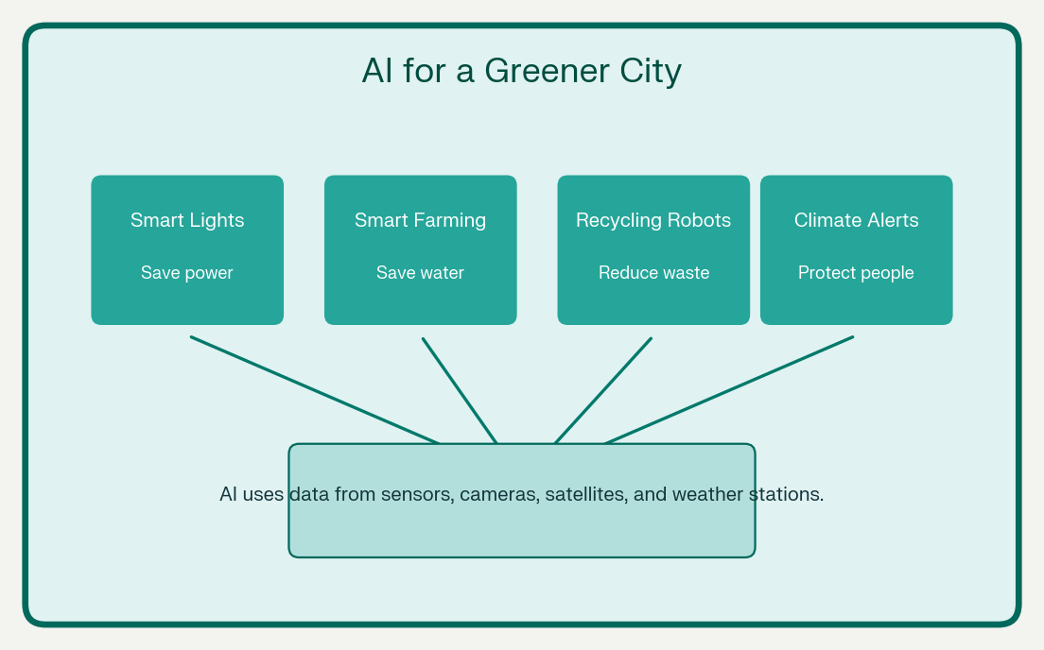
AI applications for a greener city and planet.

2.2 AI in Energy Saving
AI can reduce electricity waste by learning when buildings use the most power. Smart systems can adjust lights, air conditioners, and heating based on need.
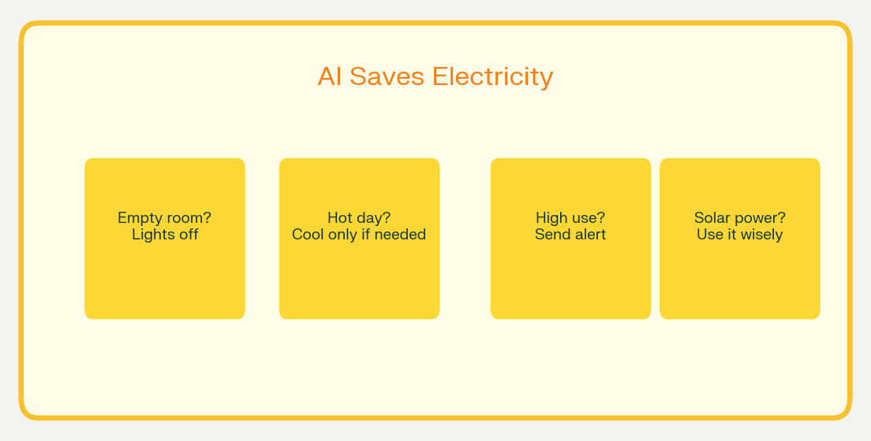
AI-controlled systems can reduce wasted electricity.
- Smart thermostats learn preferred temperatures and reduce unnecessary heating or cooling.
- Smart lighting turns lights off when a room is empty.
- AI predicts electricity demand and helps power grids use renewable energy efficiently.
- AI detects faulty machines that waste energy.
- Smart meters show families how much electricity they use.
Example
A school uses AI-controlled lights. When students leave a classroom, sensors detect no movement and the lights turn off automatically. This saves electricity and reduces the electricity bill.

2.3 AI in Farming
AI helps farmers grow food using less water, fertilizer, and pesticide. This is called precision farming or smart farming.
AI application | Environmental benefit
Crop monitoring | Cameras and drones check plant health and detect diseases early.
Smart irrigation | AI decides when and how much water crops need.
Pest detection | AI identifies pests so farmers use fewer chemicals.
Weather prediction | AI helps farmers plan harvesting and protect crops.
Soil analysis | AI suggests the right nutrients for healthy soil.

By using only the required amount of water and fertilizer, AI farming reduces waste and protects soil and nearby water sources.

2.4 AI in Waste Management and Recycling
AI can help sort waste quickly and correctly. Recycling centres use cameras and robotic arms guided by AI to separate plastic, paper, metal, and glass.
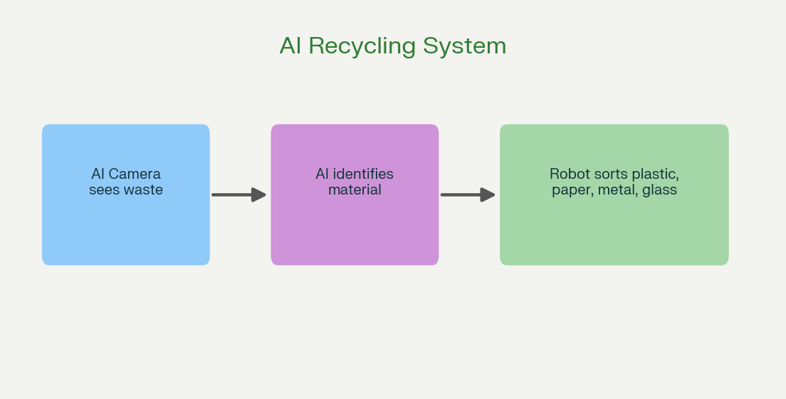
AI cameras and robots help sort recyclable materials.
- AI cameras identify types of waste on a conveyor belt.
- Robotic arms pick and sort recyclable materials.
- AI detects contamination in recycling bins.
- Smart bins signal when they are full.
- AI plans better waste-collection routes and saves fuel.
Example
An AI camera sees a plastic bottle on a conveyor belt. It identifies the material and directs a robotic arm to place it in the plastic bin. This makes recycling faster and more accurate.

2.5 AI in Climate and Nature Protection
AI can study satellite images and sensor data to monitor forests, oceans, wildlife, and weather. It can warn people about environmental dangers.
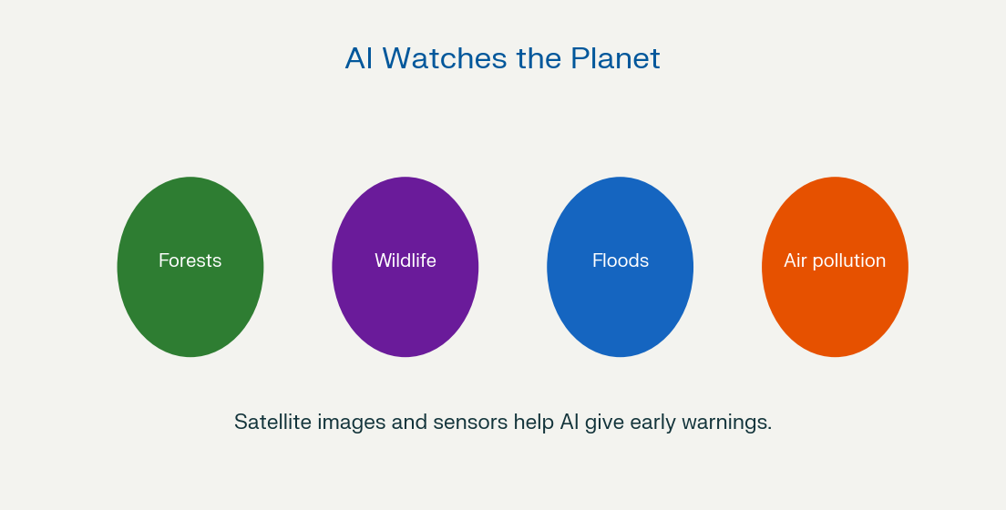
AI helps monitor nature and give early warnings.
- Forest monitoring: AI detects deforestation and illegal logging.
- Wildlife protection: AI tracks animals and helps prevent poaching.
- Disaster warning: AI predicts floods, wildfires, and storms.
- Pollution monitoring: AI measures air and water pollution.
- Ocean protection: AI identifies plastic waste and monitors marine life.
Important
AI cannot stop climate change alone. People, governments, scientists, and communities must use AI responsibly and take action.

Worksheet 2: AI for a Greener World
Name: ______________________________ Class: 7 Date: ____________

A. Choose the correct answer
- AI-controlled lights turn off when a room is: (a) noisy (b) empty (c) colourful
- Smart irrigation helps farmers save: (a) money only (b) water (c) paper
- AI recycling systems separate: (a) students (b) waste materials (c) clouds
- Precision farming uses: (a) more chemicals (b) the right amount of resources (c) no technology
- AI can warn people about: (a) floods and wildfires (b) homework only (c) birthdays

B. True or False
- AI can help detect forest fires early.
- AI farming always uses more water than normal farming.
- Smart bins can tell workers when they are full.
- AI can monitor air pollution.
- AI alone can solve all environmental problems.

C. Answer in short
- What is precision farming?
- Write two ways AI can save electricity in a school.
- How does AI help in recycling?
- Name two environmental dangers AI can help predict.
- Why is human action important along with AI?

Worksheet 3: Green AI Challenge
Match each AI application with its environmental benefit and add your own example.
AI application | Environmental benefit | Your example
Smart thermostat | Saves electricity
AI irrigation | Saves water
AI waste sorting | Improves recycling
Satellite forest monitoring | Protects forests
AI traffic management | Reduces fuel use and pollution

Design Task
Design an AI tool called GreenGuard for your school.
- What problem will it solve?
- What data will it collect?
- What action will it take?
- How will it make the school greener?
- What is one limitation of your AI tool?

Activity 2: Green School Audit
Work in groups of four. Inspect one area of your school: classroom, corridor, library, or playground.
- List three environmental problems in the chosen area.
- Suggest one AI solution for each problem.
- Draw your AI solution or make a poster.
- Explain what data the AI will use.
- Explain how students and teachers will help.
- AI lights that turn off in empty classrooms.
- AI water taps that stop leakage.
- AI bins that identify recyclable waste.
- AI fans or air conditioners that adjust based on room temperature.

Activity 3: AI Green News Reporter
Imagine you are a news reporter. Create a one-page news report about how AI helped protect the environment.
- A headline
- A location
- What happened
- How AI helped
- Who benefited
- One image or drawing
- Your reporter name
Example headline
AI Helps Village Save Water During Dry Season

Use your imagination, but keep the AI application realistic. AI can analyse weather and soil data, but it cannot create water from nothing.

Responsible Use of AI
AI is helpful, but it must be used carefully. In money matters and environmental protection, AI should support human decisions—not replace them.
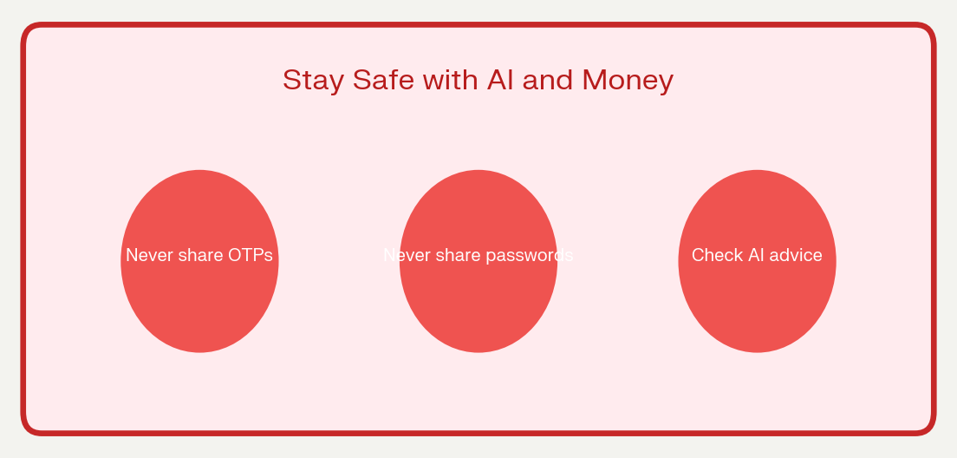
Protect your money and personal information.
- Do not share bank passwords, OTPs, card numbers, or personal information with AI chatbots.
- Check AI advice before following it.
- Remember that AI can make mistakes or show bias.
- Use AI to learn and solve problems, not to copy homework.
- Protect privacy when collecting data about people.
- Choose energy-efficient AI tools when possible.
- Report suspicious messages or fraud alerts to a trusted adult or bank.

Revision Notes
Topic | Important point
AI | Technology that learns from data and helps make decisions.
AI in budgeting | Tracks expenses, categorises spending, and suggests savings.
AI in banking | Detects unusual transactions and helps prevent fraud.
AI in energy | Controls lights and temperature to reduce electricity waste.
AI in farming | Uses the right amount of water, fertilizer, and pesticide.
AI in recycling | Identifies and sorts waste materials.
AI in climate action | Monitors forests, pollution, wildlife, and disasters.
Responsible AI | Humans must check AI decisions and protect privacy.

Final Assessment
Answer all questions.

Section A: Multiple Choice — 1 mark each
- AI helps manage money by analysing: (a) weather only (b) spending data (c) colours only
- A budget helps people: (a) waste money (b) plan money (c) forget expenses
- AI fraud detection looks for: (a) normal patterns (b) unusual transactions (c) school marks
- Smart irrigation mainly saves: (a) water (b) plastic (c) paper
- AI recycling uses: (a) cameras and robots (b) only humans (c) no data

Section B: Short Answer — 2 marks each
- Explain how AI can help a family reduce electricity bills.
- What is precision farming? Give one benefit.
- How can AI help prevent bank fraud?
- Write two ways AI can make a school greener.
- Why should AI decisions be checked by humans?

Section C: Long Answer — 5 marks
Choose one topic and write 8–10 sentences:
- How AI can help people manage money responsibly.
- How AI can help create a greener world.
- An AI invention that could help your school save energy and reduce waste.

Answer Key

Worksheet 1
A: 1. Artificial Intelligence 2. Budget 3. Fraud 4. Data 5. Prices
B: 1-b, 2-d, 3-a, 4-c, 5-e

Worksheet 2
A: 1-b, 2-b, 3-b, 4-b, 5-a
B: 1. True 2. False 3. True 4. True 5. False

Final Assessment
Section A: 1-b, 2-b, 3-b, 4-a, 5-a
Sections B and C: Students’ own answers using the theory in these notes.

Teacher Notes
- Use each worksheet after teaching the related theory section.
- Encourage group discussion during activities.
- All activities can be completed on paper without computers.
- Ask students to distinguish real AI applications from imaginary features.
- Emphasise privacy, safety, and human judgement.
- Extend learning by asking students to interview a family member about household energy or budgeting habits.
These notes introduce AI through two useful themes: responsible money management and environmental sustainability. AI can analyse financial data for budgeting and fraud detection, while environmental AI supports energy efficiency, precision agriculture, recycling, and climate monitoring.

